**LITERATURE REVIEW**

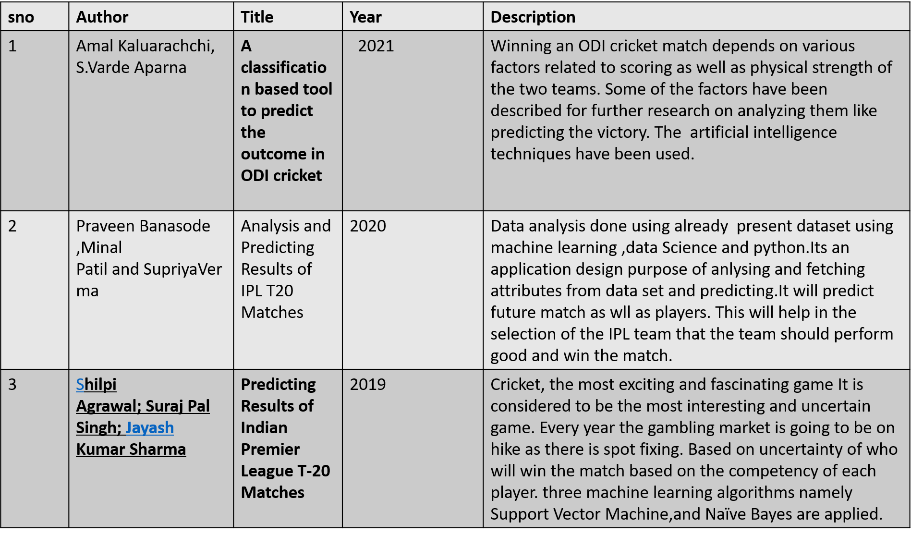

References: -

* <https://ieeexplore.ieee.org/abstract/document/5715668>
* <https://iopscience.iop.org/article/10.1088/1757-899X/1065/1/012040/meta>
* <https://ieeexplore.ieee.org/abstract/document/8820235>